Narragansett Engineering Inc.

3102 East Main Rd, Portsmouth RI 02871

T. 401.683.6630

nei-cds.com

Date + Time: 2018-04-22 14:45

to: HINGORANY NEAL K & PARMENTER AMY B 104 Dighton Ave Portsmouth RI

Plat + Lot (A.P.).: 3/ 63/ / /

Site Information: 1748-112

Latest Book and Page: 1748-112

Land evidence chain: 1281-62 438-120 106-294 106-294

Zone: R10

Lot Area (Acres): 0.18+/-

All information from Assessors Database

Narragansett Engineering Inc is please to provide you with the following proposal

Comprehensive Boundary Survey (9.2.10) (RI) 102 Construction Survey – Stake out for construction or property corners (specific features) (RI 9.4/MA) 103 Feature Location Survey (9.2.21.3) Locate or depict specific feature or features (Building Location Survey, etc.) 104 1.5 Data Accumulation Survey (Topography [T-2], Site Features, Surface Utilities Only). 105 1.5A Add subsurface utilities, and research 1.5B Add Wetland Flags 1.5C Add Tree Location 1.5D UAV Survey (for site and topography) Elevation Certificate 106   
Metes and Bounds Property Survey (MA)\* 107  
  
Conceptual Subdivision / Site Design 108  
  
CIVIL (Section 2)  
  
2.0 Feasibility Assessment, Site Concept Design. 200  
  
2.1 Proposed Site Plan (Add RIDEM / CRMC / Env. Permits) 201  
  
2.2 Soil Erosion and Sedimentation Control Plan 202  
  
2.3 Single Family Residential Stormwater Mitigation Design (Water Quality) 203  
  
2.4 Commercial – Major Land Development Drainage Design 204  
  
2.5 RICRMC Assent Application 205  
  
2.6 RIDEM Wetlands Application 206  
  
2.7 RICRMC PD Application 207  
  
ENVIRONMENTAL (Section 3)  
  
3.1 Soil Evaluation (Class IV) 301  
  
3.2 Wetlands Delineation (PWS) 302  
  
3.3 Septic System Design- New Construction Design (OWTS)   
  
3.4 Septic System Design- REPAIRS   
  
3.5 Septic System Suitability Application \*\* Fill out details  
  
3.6 RIDEM OWTS Records Review   
  
STRUCTURAL (Section 4)  
4.1 Structural Design   
  
4.2 Structural Inspection   
  
  
Design (Section 5)  
  
5.1 House or Architectural Design Consulting.  
  
  
  
Subcontractor Information (Section 6) p. 14  
  
  
  
  
  
  
  
  
  
  
  
  
  
  
  
  
  
  
s.00  
NEI Standard Hourly Rates: Jan. 2018  
  
Hourly Rates:  
  
Estimated costs are provided based on hourly rates, all fees shall be charged at the hourly rates stated. Additional work and work outside of scope shall be charged at hourly rates.  Not to exceed cost shall be billed at hourly rates or percent complete, up to, but not to exceed, the stated amount for the requisite scope of work)  
  
-Survey Crew (Field, Robotic and / or GPS):       $200 per hour   (field Survey, layouts)  
-Staff Rates:                                                         $140 per hour (design, drafting, CAD)  
-Sr. Staff (Project Manager):                                $175 per hour (structural or civil analysis)  
-Principal: $185 per hour  
-Soil Evaluator:                                                     $775 half day   (1-2 test locations and report)  
-Admin:                                                                $75 per hour   
  
  
  
Notes:  
  
Standard Notes:  
  
Any work requested outside the scope of this proposal shall be charged at current hourly rates which can be found on our website (www.nei-cds.com), or, subsequent contract terms and rates.  
Rates for professional testimony or meetings after-hours will be increased by a factor of 1.4  
Any subcontractors retained by NEI on behalf of the client shall be billed at a multiple of 1.2 times.  Sub consultants may include, but are not limited to, Professional Wetlands Scientists, Soils testing labs, Environmental Professionals, structural and materials testing, and similar services.  NEI maintains no liability as to subcontractor performance, this services is provided as a courtesy only, subcontracts shall be the direct responsibility of owner  
NEI reserves the right to disseminate any documents created in the scope of the project and recorded in the public domain to any interested third party  
Add item - may be required in addition to base fee  
Alternate item - may be alterative means to approval, alternate selection is possible.  
NEI may require construction or post-construction inspections to be performed to verify construction conforms to design plans and minimum code standards. Failure to approve or allow these inspections may compromise design goals and integrity and may limit NEI's liability in such cases.  
NEI and its consultants, partners, agents and employees shall not be liable for any and all claims, losses, expenses, injuries, or damages arising out of or any way related to this Project or this Agreement by reason or any act or omission, including breach of contract or negligence not amounting to a willful or intentional wrong, shall not exceed the total compensation received by NEI under this Agreement.  
 No filing fees (Federal, State, Local or otherwise) are included within this proposal unless note otherwise. All fees to be paid by Owner /Applicant. A $25 fee is charged for all checks paid by NEI; any checks over $500 will be required to be paid directly by client or pre-paid.  
This proposal is valid for 45 days. A retainer of $00.00 is requested with the acceptance of this if this proposal is acceptable to you, please sign one copy and return it to my office with the specified retainer. Retainer is non-refundable. Billing shall be performed at monthly intervals with retainage billed first. Invoice balances held for greater than 30 days may incur a finance charge of 2.0% per month. Balances held over 6 months may be placed in collection; including finance and collection fees.  
We reserve the right to redeposit returned checks, redeposit fees will be charged to client.  
Processing fee of up to 3% (min. $15) may be applied for credit card payments  
Credit Card payments can be made over the phone during normal business hours.  
Wire Transfers Fees:    
Payments for invoices of $1,000 or more shall not incur any wire transfer fees.  Payments of less than $1,000 shall be responsible for transfer fees.  
Work may be terminated at any time, though all items performed to date shall be billed as per percent complete or  per time spent.  
Project will not commence until retainer is paid. Nonpayment of monthly invoices may result in work delay or lower priority job status  
s.00  
  
s.012  
Survey+Site Design Notes (Sec. 1 + 2)  
Property disputes, litigation, arbitration or similar issues are not included within this proposal. Additionally, deed or property errors caused by past recording errors, encroachments, non-conforming structures, adverse possession, or takings may require additional services to resolve outside the scope of this proposal.  Meetings (outside the proposal scope) and prints shall be charged at hourly / standard rates. Abutters lists, mailings, etc. not inclusive  
Probate record search not inclusive in typical research package.  
 If owner is able to supply a current title search dating back to operative document (e.g. lot creation), discount for survey cost may be applied.  
Survey Marker + Monuments Materials Cost (Billable unless noted otherwise):  
Witness Stake - $2 / per  
Rebar + Witness Stake - $10 / per  
Pin w/ cap + Witness Stake - $15 / per  
Feno bounds w/ Stake - $85 / per  
Granite or Concrete Bounds - $200 / per\*  
\*All bounds may incur hourly rate fees due to difficulty of installation, boulders, subsurface impediments, etc.  
Significant clearing of brush or line cutting is not included unless noted. If clearing is required it shall be performed by owner or charged at hourly rates.  
Field staking trips require at minimum 48 hours prior notice, i.e. 2 business days. Stakeouts calls that are received later than this will be charged a rush rate at a multiple of 1.4. This does not guarantee service within 2 days.   
All request for survey and staking, must come through the main office, field staff may not be able to process scheduling directly.  
Stake out / construction layout procedure.  
Upon receipt of request for layout from client, NEI will prepare a Pre-Stakeout Sketch (SK) of the points desired to be set. An email will be sent to client / responsible charge displaying these points. Client will need to approve the location of points, via email, prior to item being placed on field schedule, minimum 24 hours prior to date of fieldwork.   
Upon completion, NEI will provide a Post-Stakeout SK, displaying actual points set for record information.  
NEI recommends having all survey plans recorded in land evidence. This can be performed by the owner, there is a fee to record in land evidence (varies by municipality), though a Mylar print will need to be used ($85 per).  
Any excessive issues arising during construction not due to engineering plans or specifications ie: contractor error, negligence, malfeasance, or unforeseen or unknowable site conditions (i.e.: Spearin Doctrine) or conditions arising from inclement weather and/or natural disasters are not inclusive and may require additional services outside above referenced scope of work.   
Any work required to be performed earlier than 8.00a or later than 4.30p Monday through Friday, or any work required to be performed on a weekend or Federal or State Holiday will incur overtime rates (1.5x to 2x)  
Landscape Architecture Plans or design area not inclusive unless noted otherwise  
Traffic analysis, counts, testimony not inclusive unless noted otherwise.  
Photometric Plan not inclusive unless noted otherwise.  
Geotechnical analysis or borings not inclusive unless noted otherwise.  
s.012  
  
  
s.045  
Structural + Design Notes: (Sec. 4 + 5)  
Ladder or means of access to joists must be provided by owner / rep. Joists must be made visible by removing ceiling tiles or surfacing, prior to inspection.  Limited excavation at foundation may be required - costs not inclusive.  
Verification of existing framing, foundation elements, studs, joists, and other structural members may be required to verify design and / or concept. NEI may be required to subcontract a carpenter or framer to perform limited demolition for inspection. Non-destructive testing may be possible, but this will need to be carefully coordinated with the homeowner or architect. Subcontractor costs may not be included within this proposal.  
NEI will specify sawn lumber or typical manufactured lumber (e.g. Versa Lam) material for wooden members, however we strongly recommend sending structural plans to lumber yard prior to contract award to verify member or suitable replacement is both cost effective and available.  
Improvements in flood zones: NEI strongly recommends elevation certificates be prepare pre, during and post construction, for both building code / FEMA suitability and determination of insurance rates.  Insurance rates may be a critical factor in the decision making process, substantially elevating a structure may result in a drastic improvement of rates, while construction near BFE limits may have the opposite effect. NEI recommends all structures be elevated 3' - 5' + above BFE  (as high as feasible), in accordance with RICRMC and NFIP recommendations.  
Basements, crawlspaces and areas below grade may need additional attention  in regards to water (storm / surface, groundwater and floodwaters). If gravity sub drains are not available a separate cost proposal or firm may be required to provide sump pump an waterproofing services.  There are no guarantees on basements, significant effort may be required to provide a water tight or drainage solution.  Code requires 1'+ separation to water table (which may rise over the medium to long term) and / or an adequate drainage system with sufficient backup.  
Elevations certificates can be provided $875, or less typically. Costs may vary per site.  
Verification of existing framing, foundation elements, studs, joists, and other structural members may be required  
Improvements in flood zones: NEI strongly recommends elevation certificates be prepare pre, during and post construction, for both building code / FEMA suitability and determination of insurance rates. Insurance rates may be a critical factor in the decision making process, substantially elevating a structure may result in a drastic improvement of rates, while construction near BFE limits may have the opposite effect. NEI recommends all structures be elevated 3' - 5' + above BFE (as high as feasible), in accordance with RICRMC and NFIP recommendations. Refer to RICMRC Storm tools mapping for expected sea level rise over the expected design life of the structure.  
Specialty Field Inspection Equipment Rental:  
FLIR Camera.  
Load Testing, Load Cell (up to 5,000#, unofficial)  
Walbot (RF Sensor, To find objects behind up to 4” depth walls or concrete)  
Borescope Camera   
Add $25 per hour to staff rates. NEI is not a certified materials inspection or testing lab, Inspection services provided as part of typical site or structural inspections only. GPS, Total Station, or UAV will be charged under survey rates.  
s.045  
  
  
s.01.6  
s.01.6  
  
  
  
  
  
  
  
  
  
  
  
  
  
  
  
Section 1  
Survey

NEI Standard Hourly Rates: Jan. 2018 Hourly Rates: Estimated costs are provided based on hourly rates, all fees shall be charged at the hourly rates stated. Additional work and work outside of scope shall be charged at hourly rates.  Not to exceed cost shall be billed at hourly rates or percent complete, up to, but not to exceed, the stated amount for the requisite scope of work) -Survey Crew (Field, Robotic and / or GPS):       $200 per hour   (field Survey, layouts) -Staff Rates:                                                         $140 per hour (design, drafting, CAD) -Sr. Staff (Project Manager):                                $175 per hour (structural or civil analysis) -Principal: $185 per hour -Soil Evaluator:                                                     $775 half day   (1-2 test locations and report) -Admin:                                                                $75 per hour  Notes:  
  
Standard Notes:  
  
Any work requested outside the scope of this proposal shall be charged at current hourly rates which can be found on our website (www.nei-cds.com), or, subsequent contract terms and rates.  
Rates for professional testimony or meetings after-hours will be increased by a factor of 1.4  
Any subcontractors retained by NEI on behalf of the client shall be billed at a multiple of 1.2 times.  Sub consultants may include, but are not limited to, Professional Wetlands Scientists, Soils testing labs, Environmental Professionals, structural and materials testing, and similar services.  NEI maintains no liability as to subcontractor performance, this services is provided as a courtesy only, subcontracts shall be the direct responsibility of owner  
NEI reserves the right to disseminate any documents created in the scope of the project and recorded in the public domain to any interested third party  
Add item - may be required in addition to base fee  
Alternate item - may be alterative means to approval, alternate selection is possible.  
NEI may require construction or post-construction inspections to be performed to verify construction conforms to design plans and minimum code standards. Failure to approve or allow these inspections may compromise design goals and integrity and may limit NEI's liability in such cases.  
NEI and its consultants, partners, agents and employees shall not be liable for any and all claims, losses, expenses, injuries, or damages arising out of or any way related to this Project or this Agreement by reason or any act or omission, including breach of contract or negligence not amounting to a willful or intentional wrong, shall not exceed the total compensation received by NEI under this Agreement.  
 No filing fees (Federal, State, Local or otherwise) are included within this proposal unless note otherwise. All fees to be paid by Owner /Applicant. A $25 fee is charged for all checks paid by NEI; any checks over $500 will be required to be paid directly by client or pre-paid.  
This proposal is valid for 45 days. A retainer of $00.00 is requested with the acceptance of this if this proposal is acceptable to you, please sign one copy and return it to my office with the specified retainer. Retainer is non-refundable. Billing shall be performed at monthly intervals with retainage billed first. Invoice balances held for greater than 30 days may incur a finance charge of 2.0% per month. Balances held over 6 months may be placed in collection; including finance and collection fees.  
We reserve the right to redeposit returned checks, redeposit fees will be charged to client.  
Processing fee of up to 3% (min. $15) may be applied for credit card payments  
Credit Card payments can be made over the phone during normal business hours.  
Wire Transfers Fees:    
Payments for invoices of $1,000 or more shall not incur any wire transfer fees.  Payments of less than $1,000 shall be responsible for transfer fees.  
Work may be terminated at any time, though all items performed to date shall be billed as per percent complete or  per time spent.  
Project will not commence until retainer is paid. Nonpayment of monthly invoices may result in work delay or lower priority job status

Survey+Site Design Notes (Sec. 1 + 2) Property disputes, litigation, arbitration or similar issues are not included within this proposal. Additionally, deed or property errors caused by past recording errors, encroachments, non-conforming structures, adverse possession, or takings may require additional services to resolve outside the scope of this proposal.  Meetings (outside the proposal scope) and prints shall be charged at hourly / standard rates. Abutters lists, mailings, etc. not inclusive Probate record search not inclusive in typical research package. If owner is able to supply a current title search dating back to operative document (e.g. lot creation), discount for survey cost may be applied. Survey Marker + Monuments Materials Cost (Billable unless noted otherwise): Witness Stake - $2 / per Rebar + Witness Stake - $10 / per Pin w/ cap + Witness Stake - $15 / per Feno bounds w/ Stake - $85 / per Granite or Concrete Bounds - $200 / per\* \*All bounds may incur hourly rate fees due to difficulty of installation, boulders, subsurface impediments, etc. Significant clearing of brush or line cutting is not included unless noted. If clearing is required it shall be performed by owner or charged at hourly rates. Field staking trips require at minimum 48 hours prior notice, i.e. 2 business days. Stakeouts calls that are received later than this will be charged a rush rate at a multiple of 1.4. This does not guarantee service within 2 days. All request for survey and staking, must come through the main office, field staff may not be able to process scheduling directly. Stake out / construction layout procedure. Upon receipt of request for layout from client, NEI will prepare a Pre-Stakeout Sketch (SK) of the points desired to be set. An email will be sent to client / responsible charge displaying these points. Client will need to approve the location of points, via email, prior to item being placed on field schedule, minimum 24 hours prior to date of fieldwork.   
Upon completion, NEI will provide a Post-Stakeout SK, displaying actual points set for record information.  
NEI recommends having all survey plans recorded in land evidence. This can be performed by the owner, there is a fee to record in land evidence (varies by municipality), though a Mylar print will need to be used ($85 per).  
Any excessive issues arising during construction not due to engineering plans or specifications ie: contractor error, negligence, malfeasance, or unforeseen or unknowable site conditions (i.e.: Spearin Doctrine) or conditions arising from inclement weather and/or natural disasters are not inclusive and may require additional services outside above referenced scope of work.   
Any work required to be performed earlier than 8.00a or later than 4.30p Monday through Friday, or any work required to be performed on a weekend or Federal or State Holiday will incur overtime rates (1.5x to 2x)  
Landscape Architecture Plans or design area not inclusive unless noted otherwise  
Traffic analysis, counts, testimony not inclusive unless noted otherwise.  
Photometric Plan not inclusive unless noted otherwise.  
Geotechnical analysis or borings not inclusive unless noted otherwise.

Portsmouth GIS + Aerial Map: 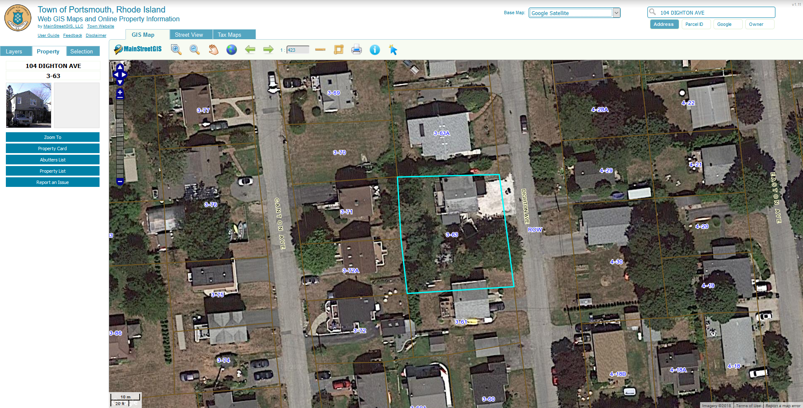

Assesors Database Information Continued: From assessors datatabase: 2018-04-22 14:45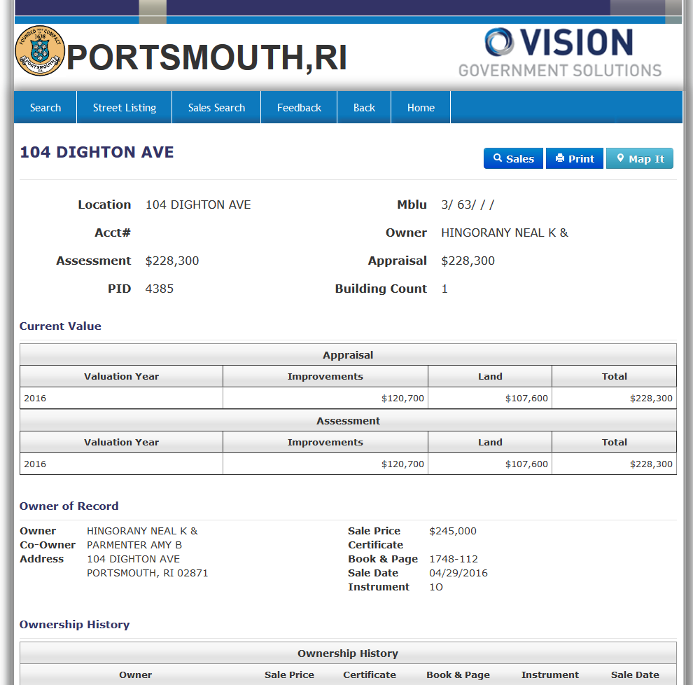

Assesors Database Information Continued: 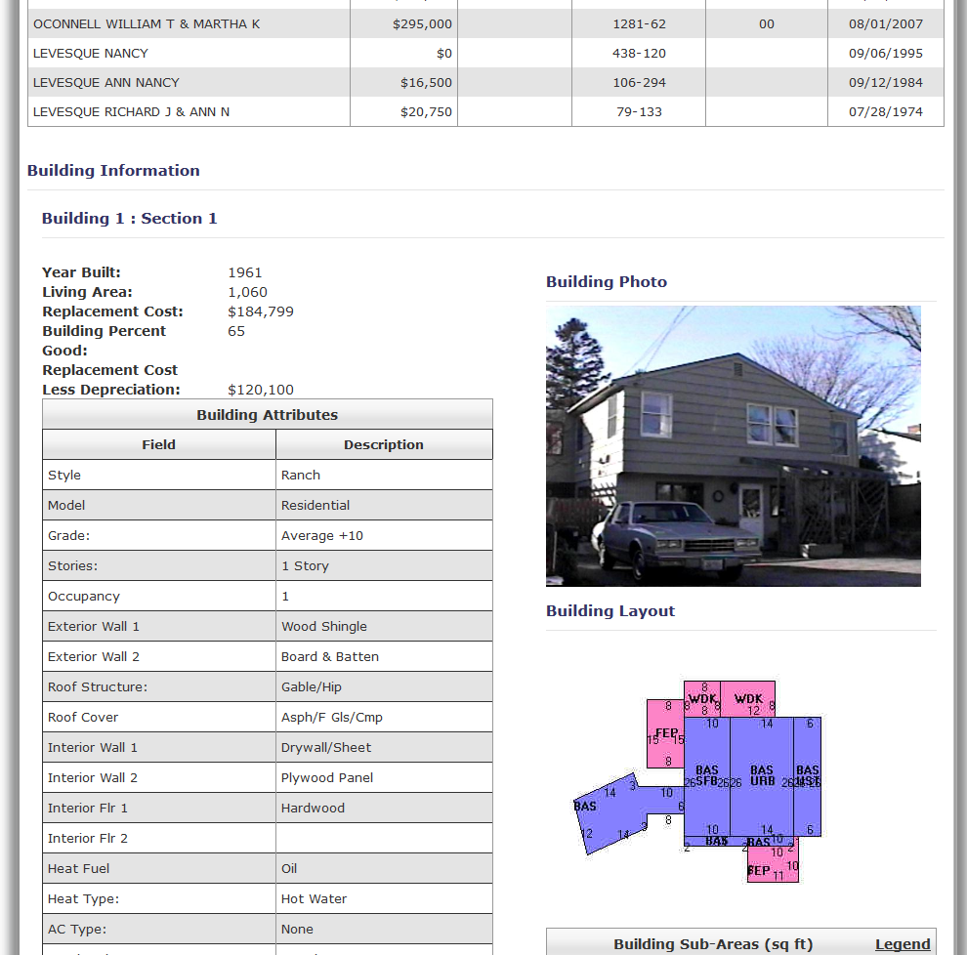

Assesors Database Information Continued: 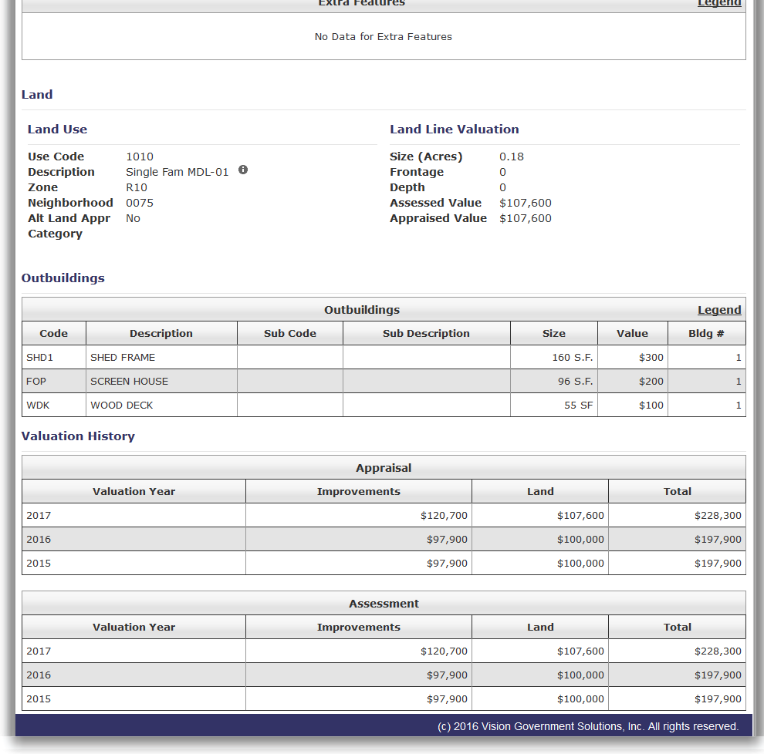

RIDEM GIS Soils, Wetlands, Flood Zone: 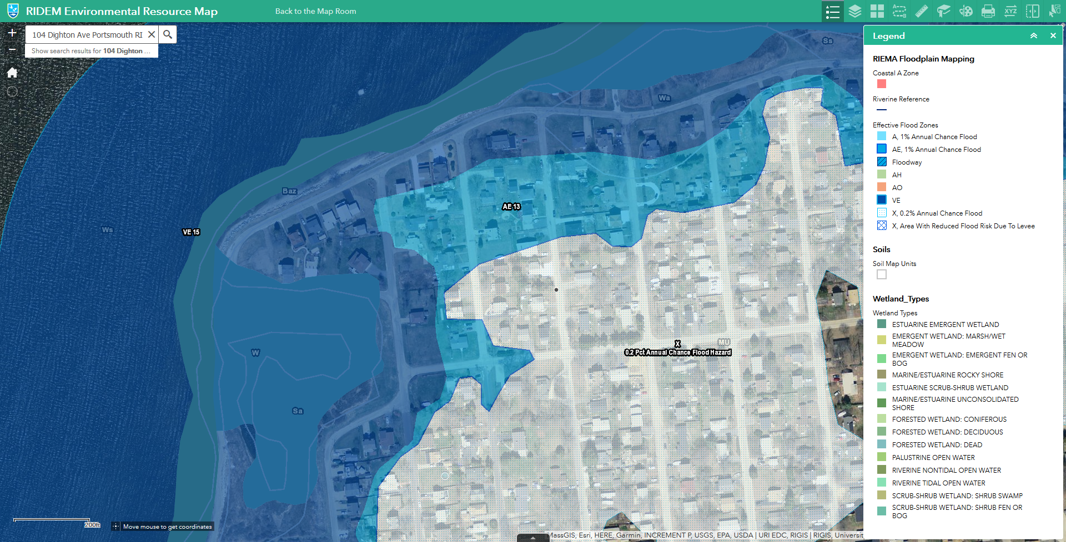

FEMA GIS Information: 